**Excel Task on E-Fixed Deposit**

Q1) Create a bar graph showing the FD sales for different periods of investment. Draw two bar graphs: one for normal users and other for senior citizens. label the chart drawn correctly so that senior management gets a clear report of sales.

Ans) The bar graph of Fixed Deposit for normal users is mentioned below:

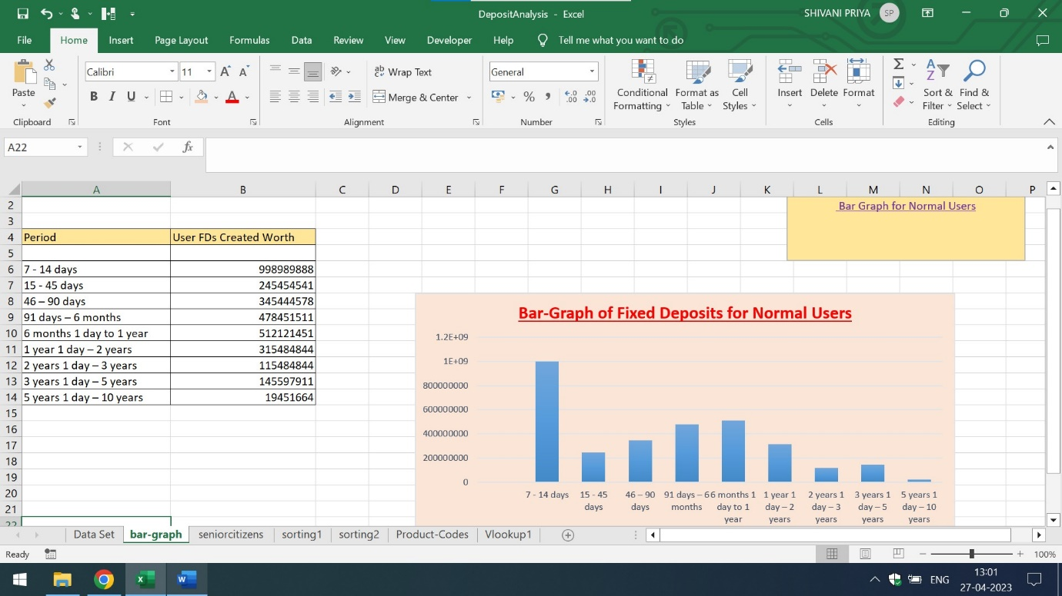

The bar graph of Fixed Deposit for senior citizens is mentioned below:

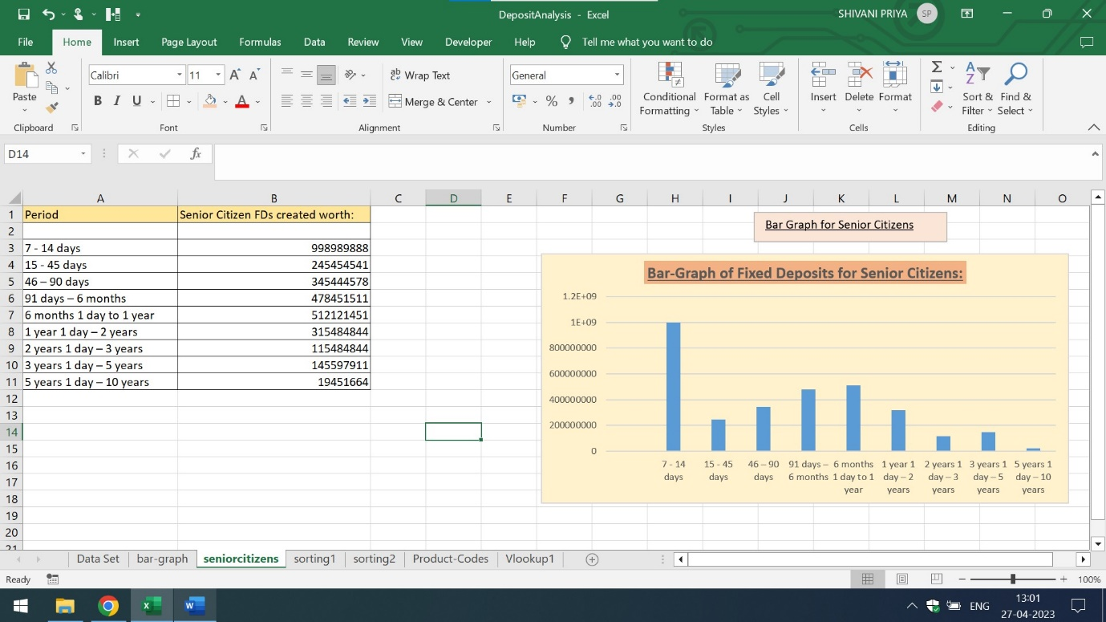

Q2) Arrange the data above in excel in ascending and in descending order

Ans) The representation of tabular data in ascending order is mentioned below:

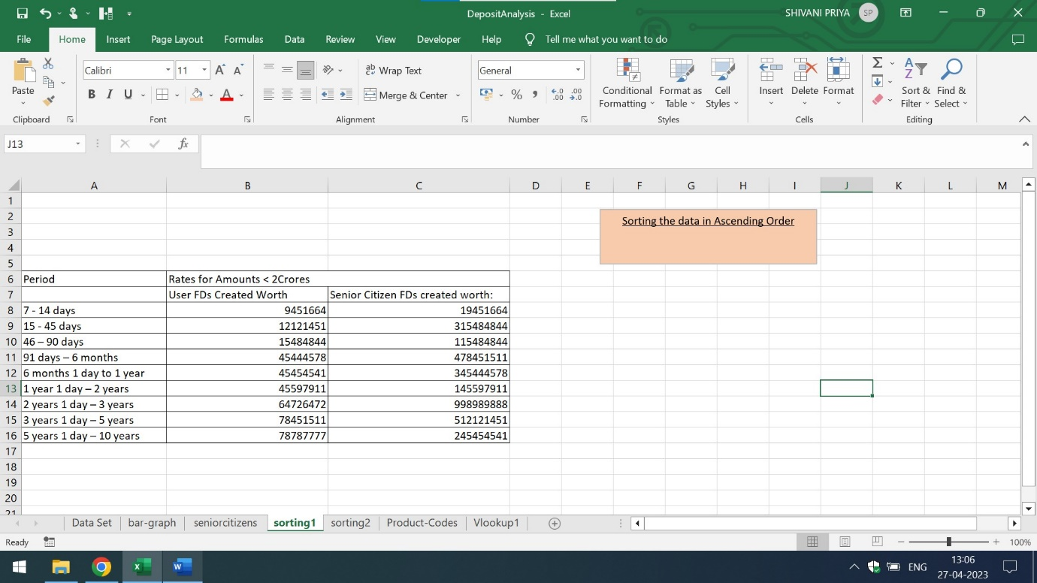

The representation of tabular data in descending order is mentioned below:

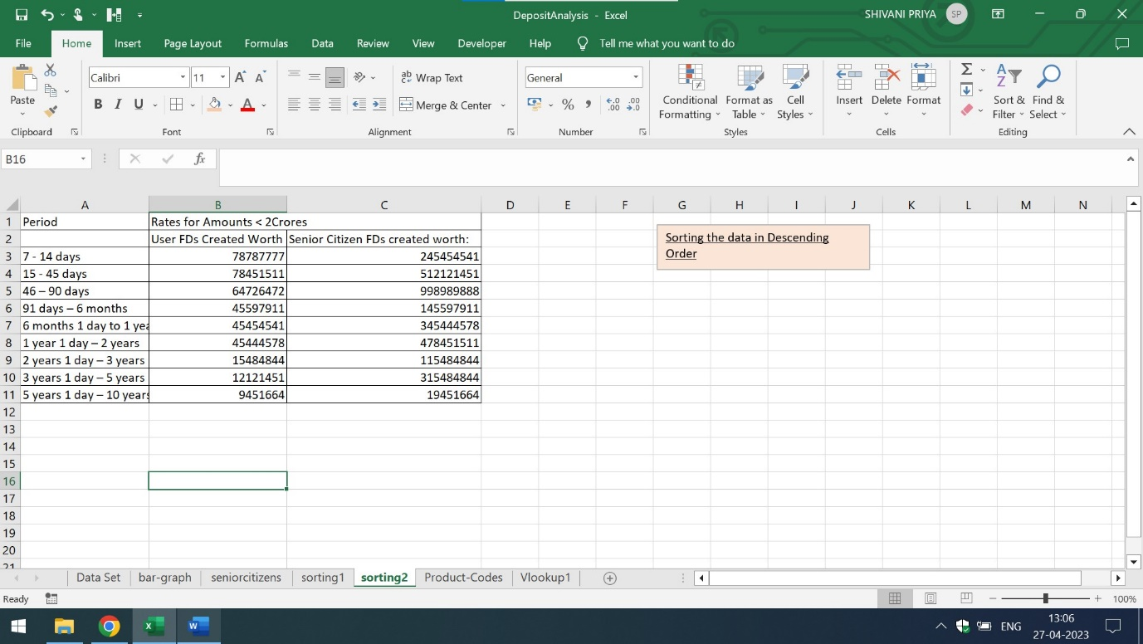

Q3) Using vlookup for product code HDH, find the rate for senior citizens for amounts less than 2 crore.

Using vlookup for product code YFF, find the rate for senior citizens for amounts less than 2 crore.

Ans) The rates for senior citizens for product code HDH and YFF for amounts less than 2 crore is mentioned below:

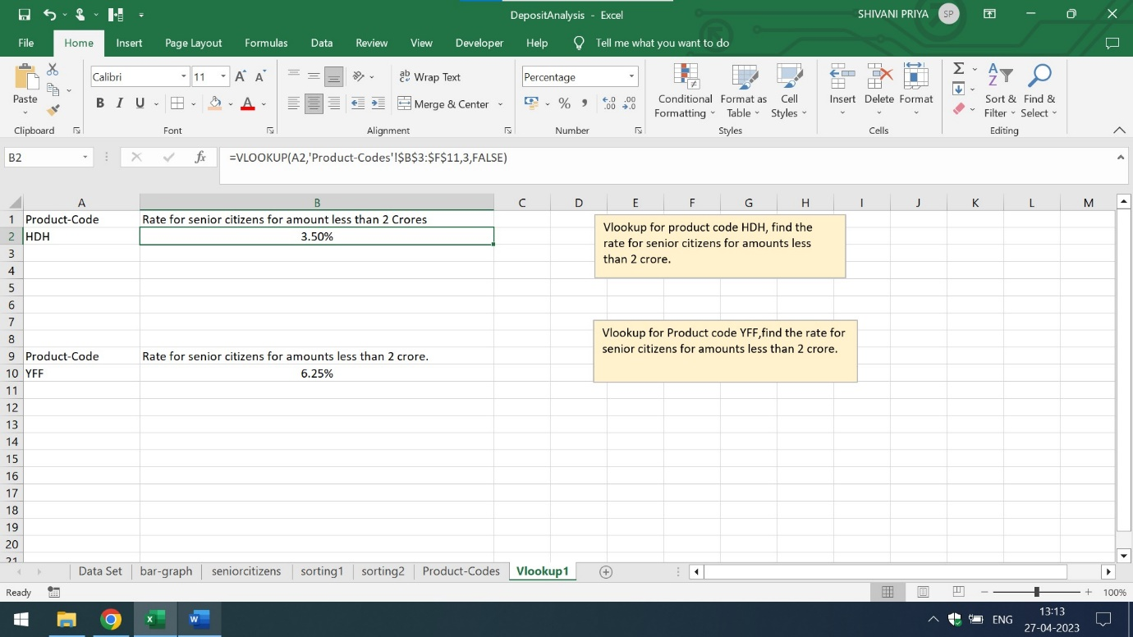

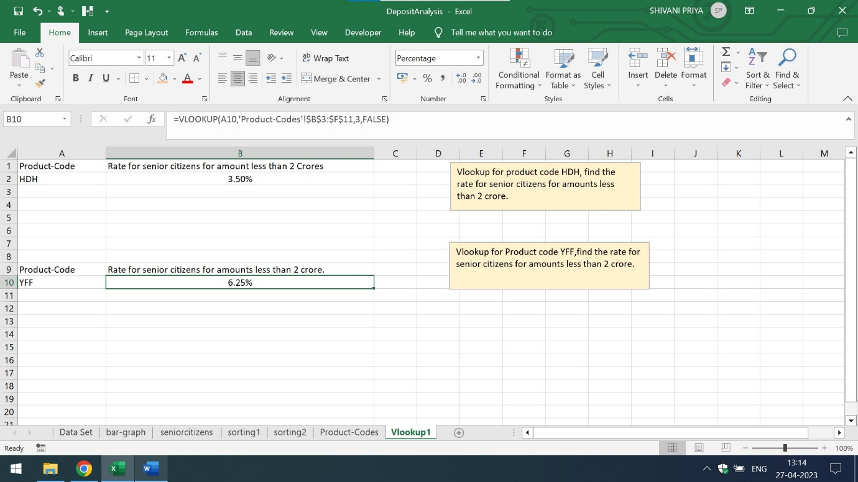

Kindly click on the below mentioned link

<https://github.com/shivanipriya89/E-Fixed-Deposit>

and download the excel sheet for more detailed explanation